Chapter 18, Solution 55.

f(t) = 5e²e^{–t}u(t)

F(ω) = 5e²/(1 + jω), |F(ω)|² = 25e⁴/(1 + ω²)

W_{1Ω} = 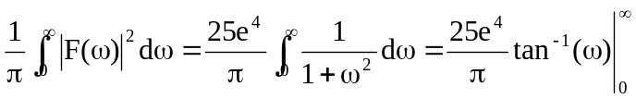

= 12.5e⁴ = 682.5 J

or W_{1Ω} = 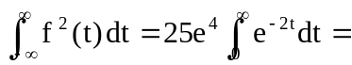 12.5e⁴ = 682.5 J

